Quality of the Week:
Balance
- an even distribution of weight
- An even distribution of knowledge and activity
Alexander CALDER
Artist of the Day:
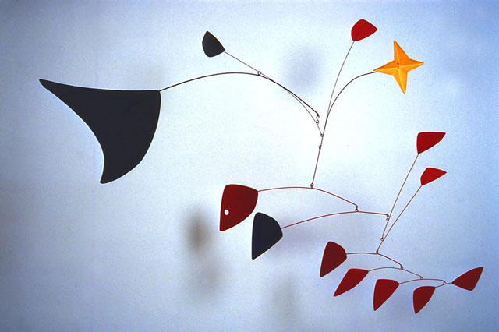
Artists of the Past
Mostly created sculptures and kinetic art
Kinetic Art: Art that actually moves
Time Period: mid 1900s
What can you learn from Calder’s sculptures?
How should you create a balance in your life?
Artist | Movement or Style of Art | Nationality | Famous Artworks
Pablo Picasso  Early 1900s | Cubism, Abstract | Spanish | 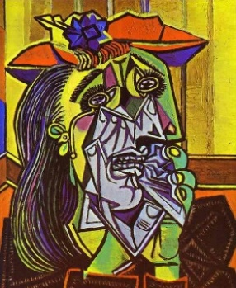
Andy Warhol  Mid 1900s (1960s) | Pop-Art  -Repetition | American | 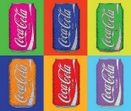
Milton Glaser  Late 1900s | Graphic Design | American | 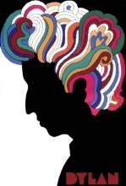
Kandinsky  Early 1900s | Abstract | Russian/French | 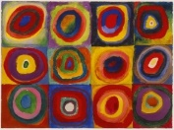
Cézanne | Transition from Realism to Abstraction | French | 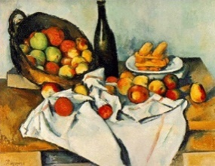
Van Gogh | Semi-realistic: Influenced by his own style  (Post-Impressionism) | Dutch | 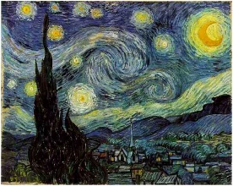
Degas | Impressionist/Realist  -Movement | French | 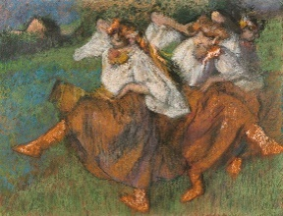
Giacometti | Surrealism  -Sculpture | Swiss | 