Quality of the Week:
Reflection
- thinking about past actions and seeing how you could be better in that situation
Expressionism
Movement of the Week:
- Abstract (not real)
- Expresses (shows) emotions
Artist of the Day: ALMA THOMAS (1900s)
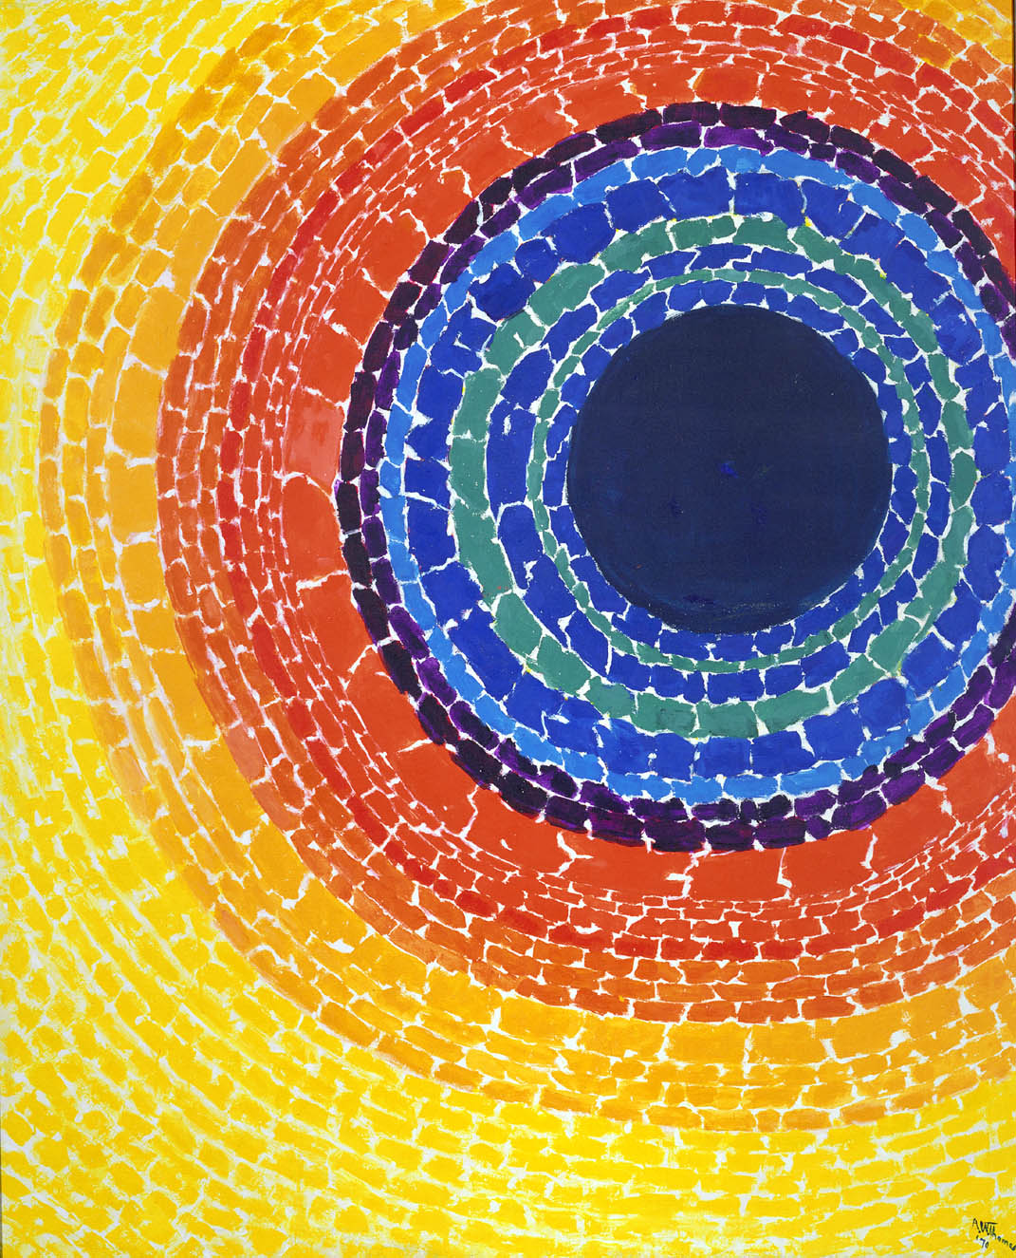
Vocabulary
Eclipse
Rhythm
Mosaic
Fun facts about Alma Thomas:
- First showed the world her work when she was 75 years old
- Had her paintings put in the White House three times
The Eclipse

