Quality of the Week:
Creativity
- The use of your imagination in order to create things or solve things
Pottery
Concept of the Day:
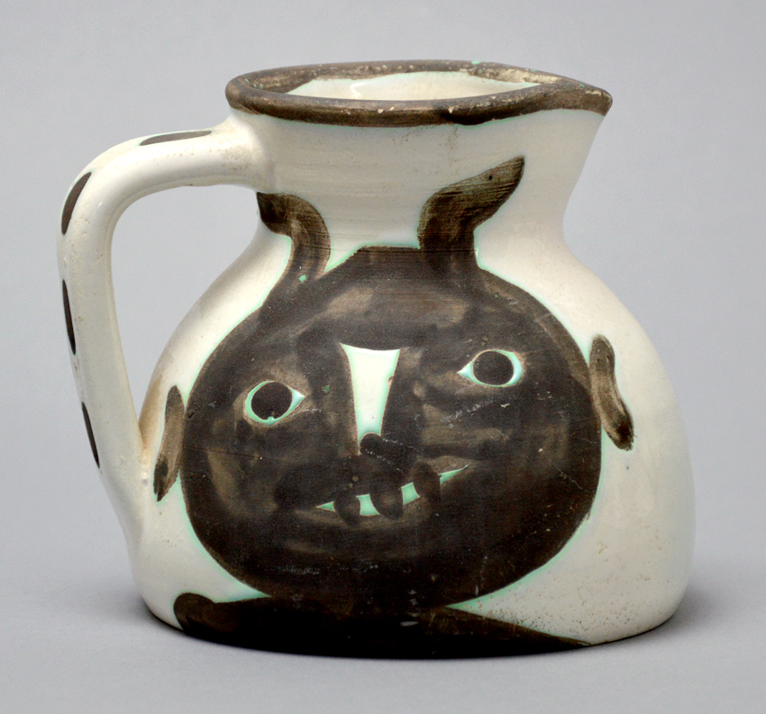
Artists of the Past
- Pottery
  - How did/do other cultures use clay in their everyday lives?
- Pottery can be created for many different purposes
  - If pottery is created for art and for containers or use in everyday life, are both forms of pottery art?
  - What defines art?
- Today, be creative and put your own impression on your work

Artist | Movement or Style of Art | Nationality | Famous Artworks
Pablo Picasso  Early 1900s | Cubism, Abstract | Spanish | 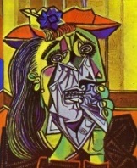
Andy Warhol  Mid 1900s (1960s) | Pop-Art  -Repetition | American | 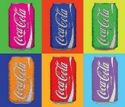
Milton Glaser  Late 1900s | Graphic Design | American
Kandinsky  Early 1900s | Abstract | Russian/French | 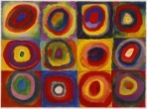
Cézanne | Transition from Realism to Abstraction | French | 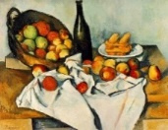
Van Gogh | Semi-realistic:  (Post-Impressionism) | Dutch | 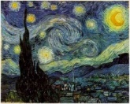
Degas | Impressionist/Realist  -Movement | French | 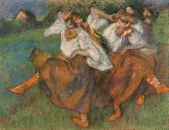
Giacometti | Surrealism  -Sculpture | Swiss | 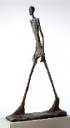
Calder | Kinetic Art  Sculpture  -balance | American | 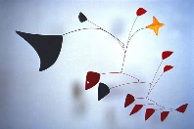
Monet | Impressionism | French | 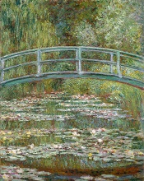
Mondrian | Modern Art  Abstract | Dutch | 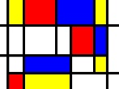
Rivera | Murals  -Symbolism  -beauty of hard work | Mexican | 