Quality of the Week:
Hard-Working
- Working with a lot of energy and commitment
Diego Rivera
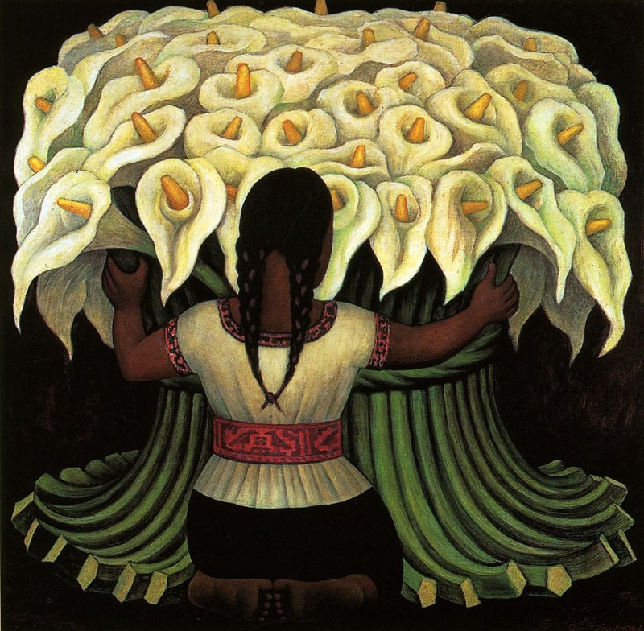
Artist of the Day:
Artists of the Past
Born in Guanajuato, Mexico in 1886
Part of Mexican Muralist Movement
Murals are paintings done on large scale such as walls.
Uses symbolism
Symbolism is using objects to represent abstract ideas.
He often used symbols to represent his Mexican culture
This painting has a worker carrying calla lies to represent the beauty of hard work.

Artist | Movement or Style of Art | Nationality | Famous Artworks
Pablo Picasso  Early 1900s | Cubism, Abstract | Spanish | 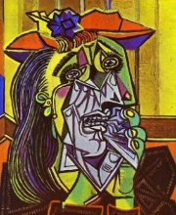
Andy Warhol  Mid 1900s (1960s) | Pop-Art  -Repetition | American | 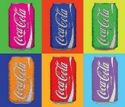
Milton Glaser  Late 1900s | Graphic Design | American
Kandinsky  Early 1900s | Abstract | Russian/French | 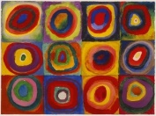
Cézanne | Transition from Realism to Abstraction | French | 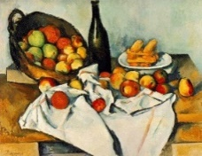
Van Gogh | Semi-realistic: Influenced by his own style  (Post-Impressionism) | Dutch | 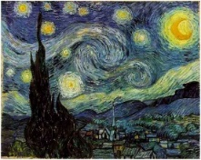
Degas | Impressionist/Realist  -Movement | French | 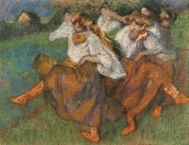
Giacometti | Surrealism  -Sculpture | Swiss | 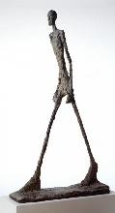
Calder
Monet
Mondrian
Rivera

