Quality of the Week:

Giacometti
Artist of the Day:
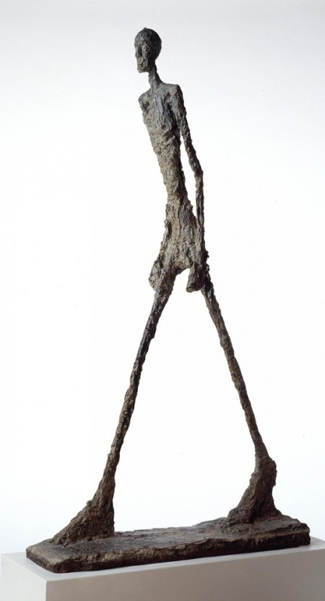
Style of Art: Surrealism
Time Period: Mid 1900s
Many of his artworks are inspired from gesture drawing
3D vs. Relief
-Difference?
Is a sculpture 3D or a Relief?
- What can a sculpture be made out of?
- What experience do you have with sculptures?

Artists of the Past
Artist | Movement or Style of Art | Nationality | Famous Artworks
Pablo Picasso  Early 1900s | Cubism, Abstract | Spanish | 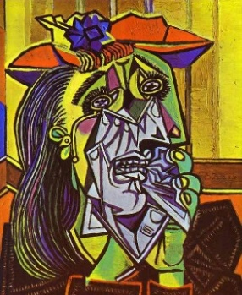
Andy Warhol  Mid 1900s (1960s) | Pop-Art  -Repetition | American | 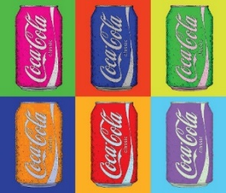
Milton Glaser  Late 1900s | Graphic Design | American | 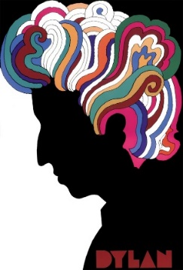
Kandinsky  Early 1900s | Abstract | Russian/French | 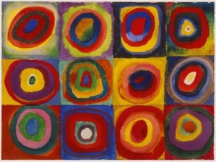
Cézanne | Transition from Realism to Abstraction | French | 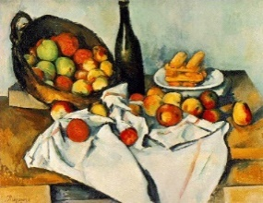
Van Gogh | Semi-realistic: Influenced by his own style  (Post-Impressionism) | Dutch | 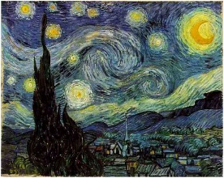
Degas | Impressionist/Realist  -Movement | French | 